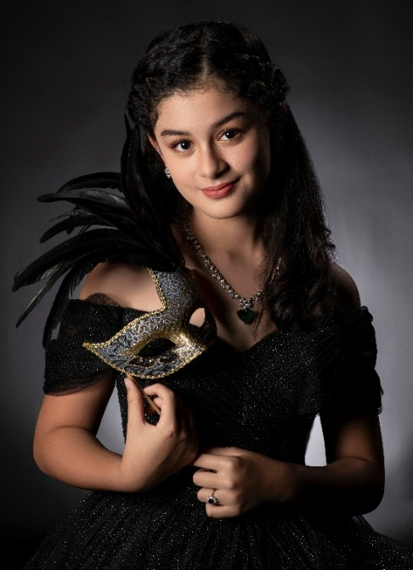

TRUE (TRUE EL-DEEB)
Genre : Pop / Contemporary / Indie / R&B
Location : Singapore / Malaysia
Nationality: British
Email : mikedeeb@aol.com
Tel : +65 9737 7037 (Parent)

At just 12 years old, TRUE is an astonishing vocalist and emerging singer-songwriter already demonstrating artistic maturity far beyond her years. A British national currently based between Singapore and Malaysia, TRUE has performed as both a solo vocalist and musical theatre lead. Her performance résumé includes notable appearances on prestigious stages such as Carnegie Hall (NYC), St. Peter’s Church (NYC), Singapore Victoria Concert Hall, The Singapore Esplanade, and CHIJMES.
TRUE’s voice is silky, emotive, and powerful—drawing influence from iconic vocalists such as Whitney Houston, Celine Dion, and Christina Aguilera. She is equally at home delivering powerhouse ballads such as I Will Always Love You, All By Myself, and Bound to You, or performing softer contemporary pop in the style of Laufey, and Suzanne Vega.
Blending modern pop melodies with elements of R&B, TRUE creates a sound that feels intimate, expressive, and timeless. Her tone and delivery reflect a rare emotional sensitivity, allowing listeners to immediately connect with her authenticity and storytelling.
Passionate about expressing truth through music, TRUE is committed to pursuing her journey as a recording and performing artist and is eager to connect with her global audience.
✦ True is a classically trained vocalist and plays piano and guitar

Artistic Vision
“Hi, I’m True. I create music for anyone who’s ever felt invisible, misunderstood, or unsure where they belong. I write about things we sometimes find hard to share, things we keep inside. I also write about lots of fun things and happy times. But my songs are always about real emotions, real stories; so when you listen to me you are never alone.”
True El - Deeb

A young voice with timeless emotion

